**NEWS**

**Researcher from CREB, Lahore School of Economics, represents South and East Asia in the conference on Advances with Field Experiment at University of Chicago, Illinois, USA**

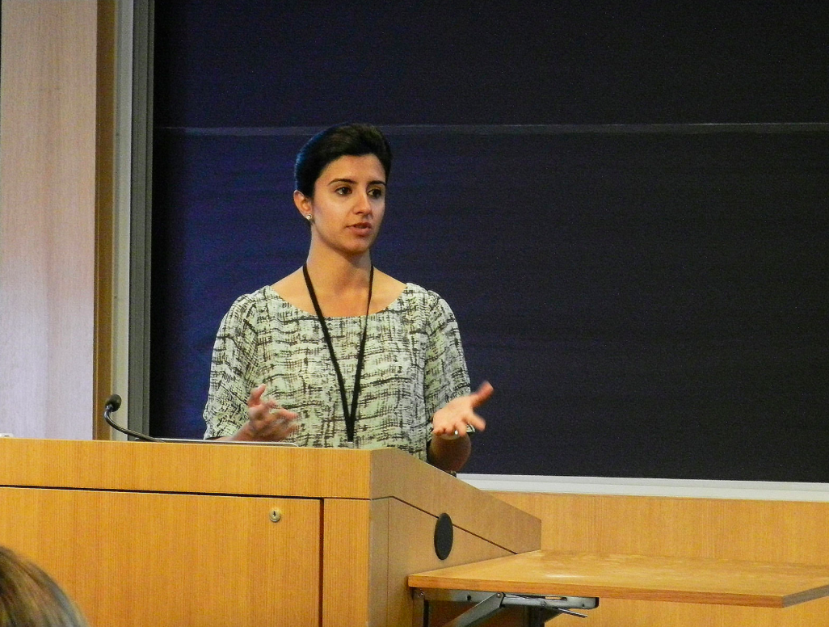

Ms. Farah Said, Assistant Professor & Research Fellow at CREB , Lahore School of Economics, with researchers from the University of South California ,Tufts, University of Pennsylvania , Harvard, Yale , Columbia ,UC Berkley, London School of Economics, NYU, etc. attended the conference on innovative economic field experiments held at University of Chicago, Illinois , USA on 15-16th September ,2016. This year, the conference was hosted by the Department of Economics, University of Chicago and was organized by Dr. John List, Dr. Robert Metcalfe (University of Chicago) and Dr. Anya Samek (University of South California). Ms. Said presented her work on instrumental and pure demand for agency shown in households in Pakistan. This paper attracted feedback and was greatly lauded by the dignified audience. Ms. Said was the only researcher from South and East Asia who presented paper in the conference.

______________________________________________________________________________

**Lahore School of Economics Undergrad Students Visit Macquarie University, Australia on Study Tour in August, 2016**

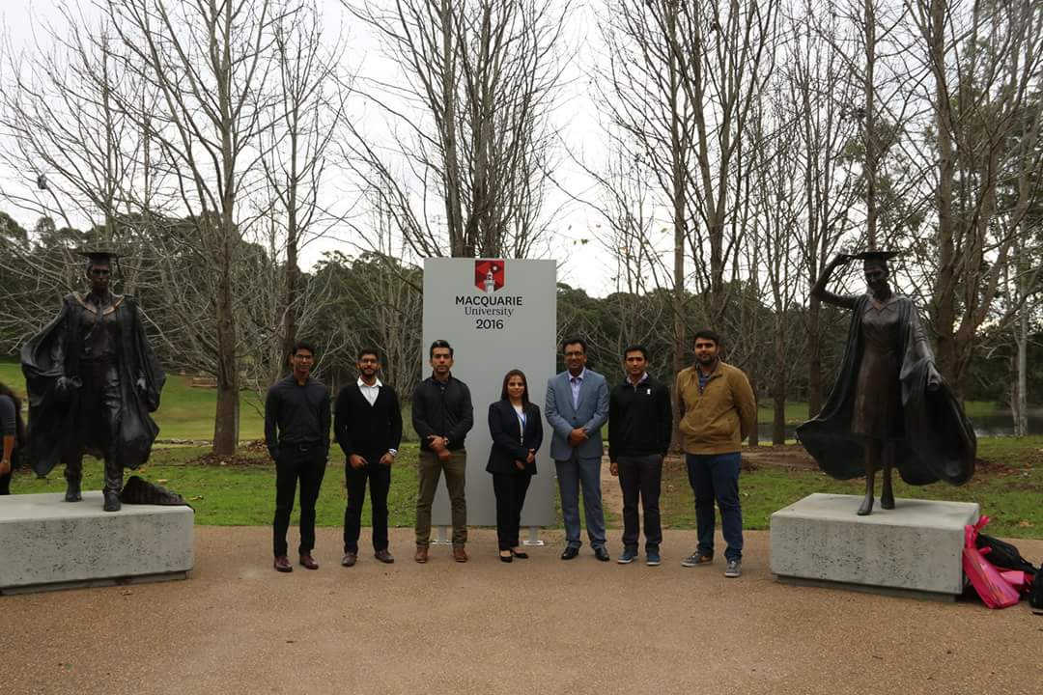

The Lahore School of Economics arranged a two week study tour for five of its students at the Macquarie University, Australia in August, 2016. These students had the opportunity to interact with their fellow students from the host university and attend special class on Social Entrepreneurship by Associate Professor, Debbie Haski. The student also went site seeing in Sydney.

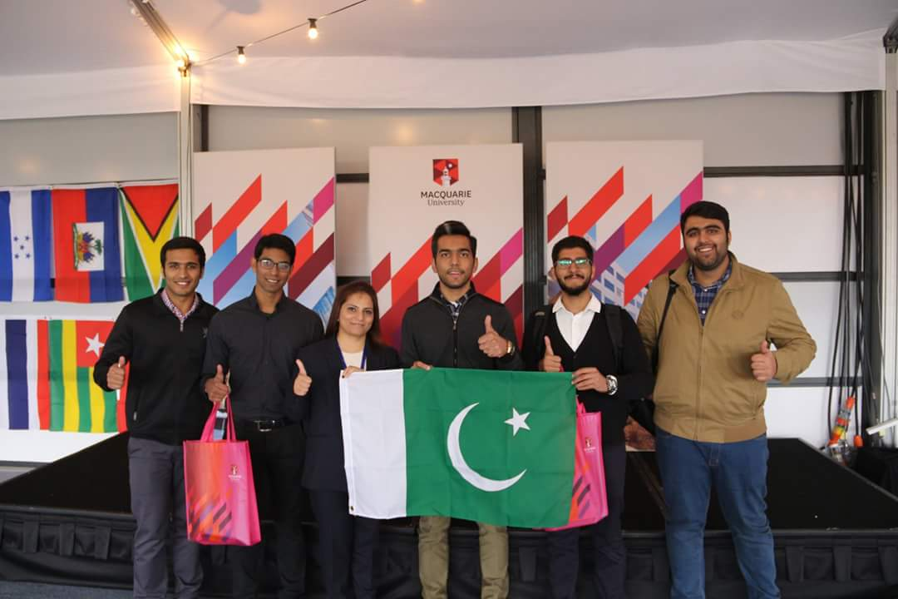

Hamza Sadiq, Abdullah Nadeem, Ameer Hamza, Qasim Naeem and Zoraiz Chaudhry are among students who visited Macquarie University, Australia. Ms. Sehrish Ehtisham, Manager, External Relations, LSE, guided them in the tour.

**______________________________________________________________________________**

**SEEDEC Conference attended by delegate from CREB, Lahore School of Economics**

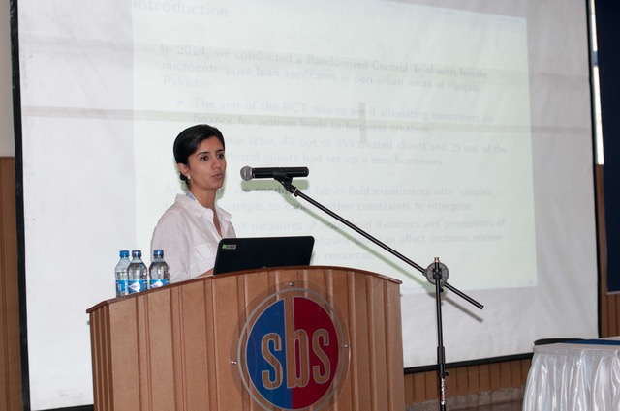

The Symposium on Economic Experiments in Developing Countries (SEEDEC) is an important and leading conference held every year and this year it was arranged at Nairobi, Kenya in the campus of Strathmore Business School hosted by “Busara Centre for Behavioral Economics” from 12th July to 13th July, 2016. The research presented in the conference is at the forefront of the Behavioral and Experimental Economics. Ms. Farah Said, Assistant Professor and Research Fellow, Centre for Research in Economics & Business (CREB), Lahore School of Economics attended and presented her research work on agency shown in female micro-entrepreneurs in Pakistan, which was well received by the audience. The junior academics and researchers from UC Berkeley, Princeton, Oxford, Stanford, Duke, Michigan, Houston, Gottingen and Maastricht also attended this conference.

**Ms. Ayed Syed attends the 8th Annual American Business Research Conference held in New York**

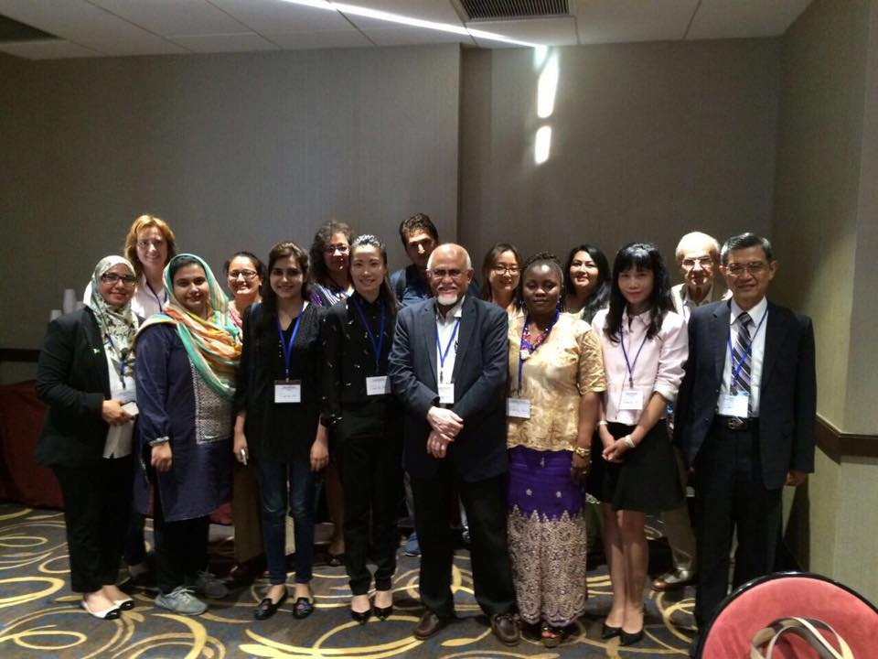

Ms. Ayesha Syed from the Lahore School of Economics presented her paper titled “Fuzzy Judgment Aggregation: Distance Based Methods” at the 8th Annual American Business Research Conference held in New York, USA from 11 – 12 July, 2016. The theme of the conference was “Research for change” and delegates from 16 countries from multiple disciplines presented their work. Ms. Syed’s paper was published in the conference proceedings.

**LSE Students Visit University of Colombo, Sri Lanka on Study Tour in July, 2016**

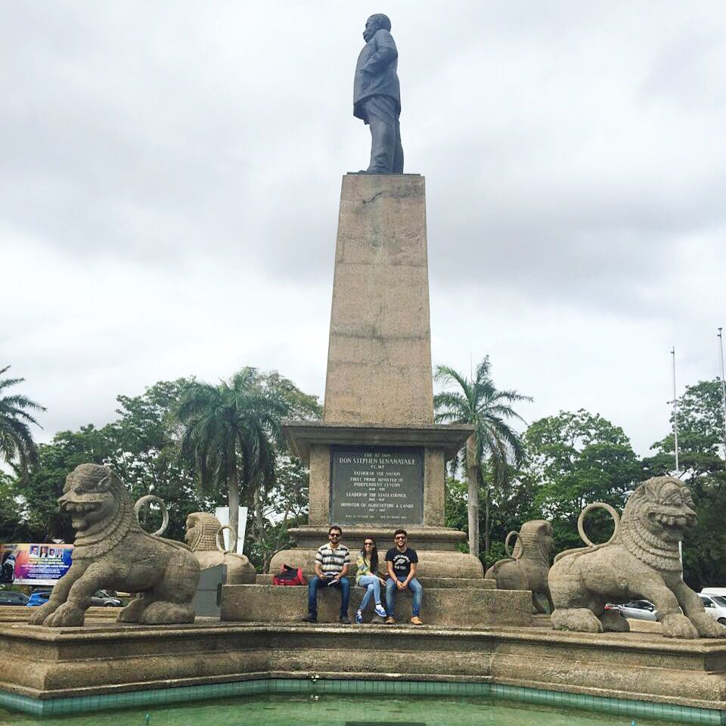

The Lahore School of Economics arranged a four week study tour for three of its undergraduate students to the University of Colombo, Sri Lanka in July, 2016. The study tour focused on subjects like economics of tourism development and research methods .The students learned how to use SPSS and its utility in data analysis for conducting research. The students also visited various places of historical, cultural and heritage importance and interacted with local people.

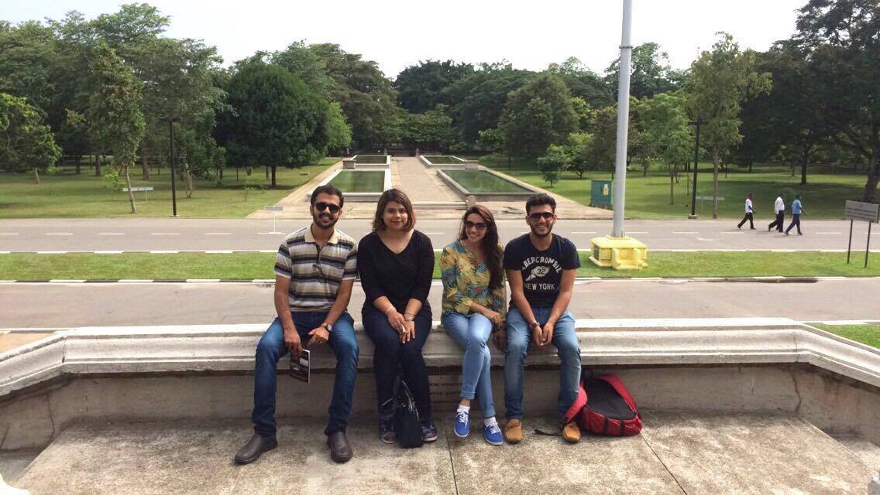

Abdullah Sajjad, Khawaja Humail Mueen Koreja and Meenal Qadir Khan are among students who participated in the study tour hosted by the University of Colombo, Sri Lanka. These students were accompanied by Ms. Ayesha Khaled, Assistant Registrar, External Relations, Lahore School of Economics.

**Warwick University, UK hosts PhD Scholars from Lahore School of Economics**

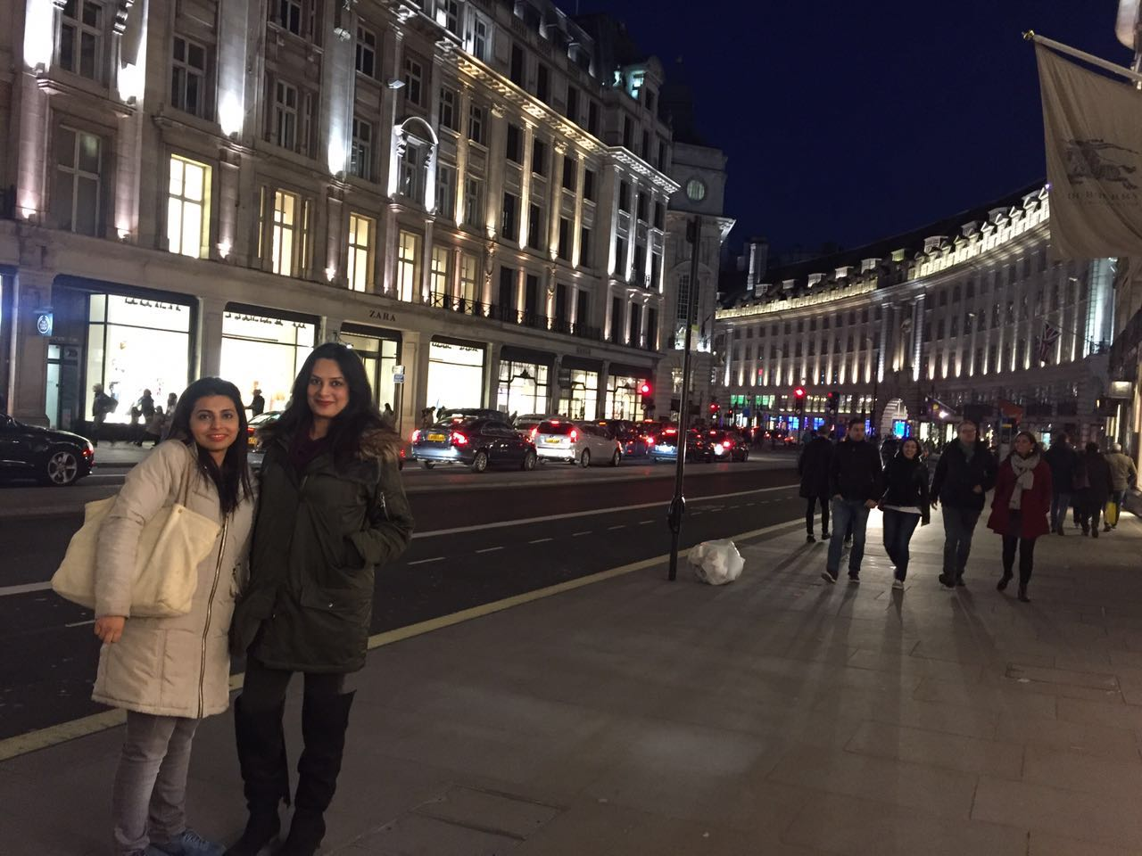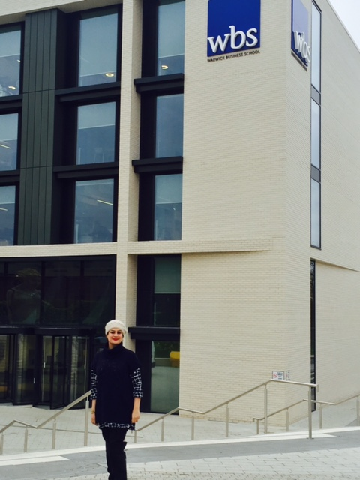

PhD. Economics students from the Lahore School of Economics went for a student exchange program to Warwick University, UK for the students’ exchange for PhD. Economics students. Ms. Nida Jamil and Ms. Rabia Arif, were the first graduate PhD. scholars from the Lahore School of Economics to visit Warwick University for a month in March, 2016. These students were guided and supervised by Professor Rocco Macchiavello and these students had the opportunity to attend the lectures of some of the top economists in the world including Christopher Woodruff. The visiting students also received necessary research guidance on their PhD proposal to further refine their research ideas and to develop their research work.

___________________________________________________________________________

**Ms. Mahnoor Asif, Teaching Fellow, Department of Economics, Lahore School of Economics, presents research paper at CSAE, University of Oxford, UK**

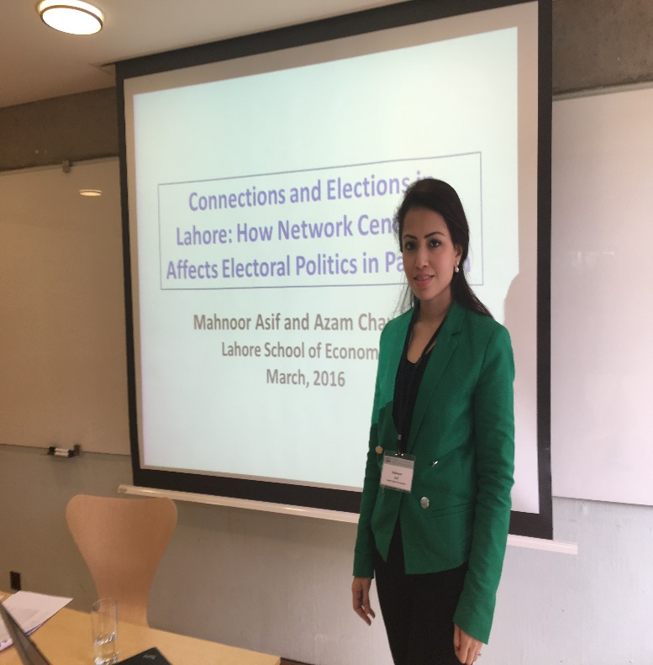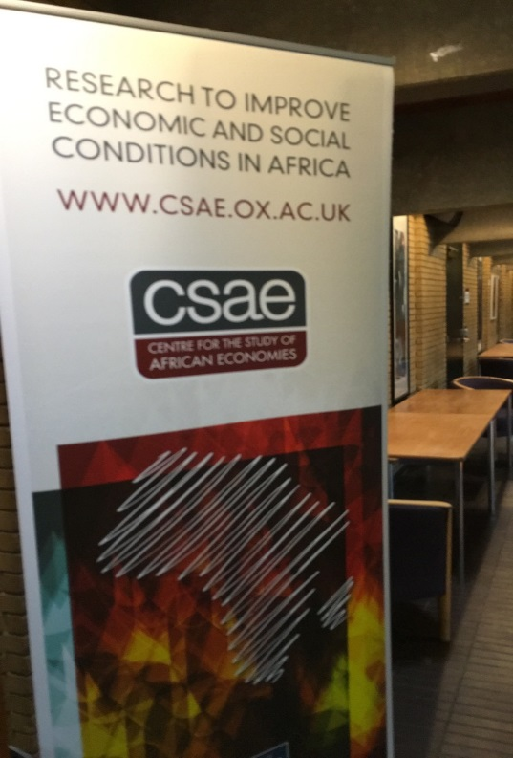

Ms. Mahnoor Asif, Teaching Fellow, Department of Economics, Lahore School of Economics a attended a conference held on March 20th-22nd, 2016 in the Centre for the Study of African Economics (CSAE) at St Catherine's College, Oxford, UK. The paper she presented " Connections and Elections in Lahore: How Network Centrality Affects Electoral Politics in Pakistan " which was extremely well received by her fellow researchers.

**PhD students of LSE visit Oxford University, UK**

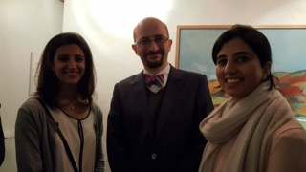

The Lahore School of Economics has an ongoing arrangement with Oxford University, UK for a graduate students’ exchange for PhD. Economics students. Two PhD. Economics students, Ms. Rabia Ikram, Assistant Professor & Research Scholar at the Lahore School of Economics and Ms. Farah Said, Assistant Professor & Research Fellow of CREB visited Oxford University, UK under this program in January, 2016. During the month's stay, the visiting scholars had interacted with a variety of researchers including Karlijn Morinsk, a post doc at Oxford, Stefano Caria (lecturer at the University of Oxford), Rocco Macchiavello (University of Warwick) and Anandi Mani (University of Warwick). They also attended graduate seminars at the University of Oxford.

_____________________________________________________________________________________

[**Innovation and Technology Centre of the Lahore School of Economics Launches Sialkot Football Project**](http://lahoreschoolofeconomics.blogspot.com/2015/08/innovation-and-technology-center-of.html)**:**

Dr. Azam Amjad Chaudhry, Dean and Professor, Lahore School of Economics and Shamyla Chaudry, Assistant Professor, Lahore School of Economics conducted the rexine subsidy event on 12 August 2015 in order to help Sialkot football manufacturers overcome the high cost of imported rexine. In this project more than 70 firms from the Sialkot football sector were invited to an event in which 30 firms were selected to receive high value vouchers from the Lahore School of Economics that can be used to purchase high-quality foreign Rexine at a large discount.

**[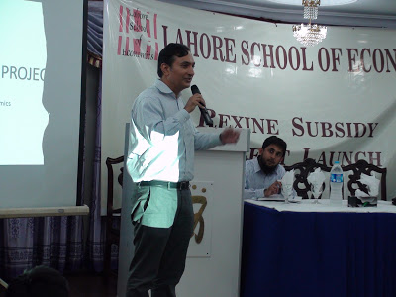](http://2.bp.blogspot.com/-YVkuktay_Vc/VdcVy39MXMI/AAAAAAAANk0/nf7-6pIII6g/s1600/dr+azam+chaudhry.jpg)**

**Dr. Azam Amjad Chaudhry of the Lahore School of Economics formally launches Sialkot football rexine project**

Dr. Chaudhry also discussed the plan to launch an innovation fund to promote innovative ideas in Punjab. Dr. Eric Verhoogen from Columbia University also discussed the trends in Pakistani football exports and how manufacturers will need to focus on productivity to compete with global players like China.

**[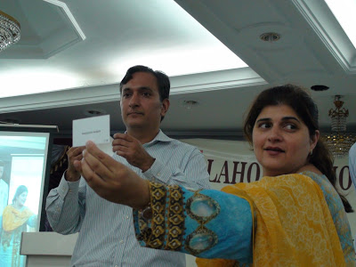](http://3.bp.blogspot.com/-l0bVsmjgLO4/VdcWL7XoGXI/AAAAAAAANk8/V_zzEBQ-COg/s1600/azam+chaudhry.jpg)**

**Dr. Azam Amjad Chaudhry and Ms. Shamyla Chaudry of the Lahore School of Economics select firms to receive football rexine subsidies**

**[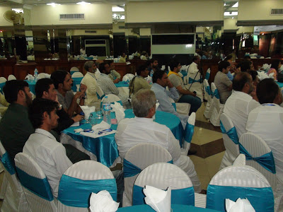](http://2.bp.blogspot.com/-Aum2Bn4a0dk/VdcW88Qb_QI/AAAAAAAANlE/7pvDWOoZ5yE/s1600/lse.jpg)**

**Participants from the Sialkot football sector and Sialkot chamber of commerce attend launch of the Lahore School of Economics rexine project**

**Six Undergraduate LSE students attend a semester in Bahcesehir University, Istanbul, Turkey in 2015**

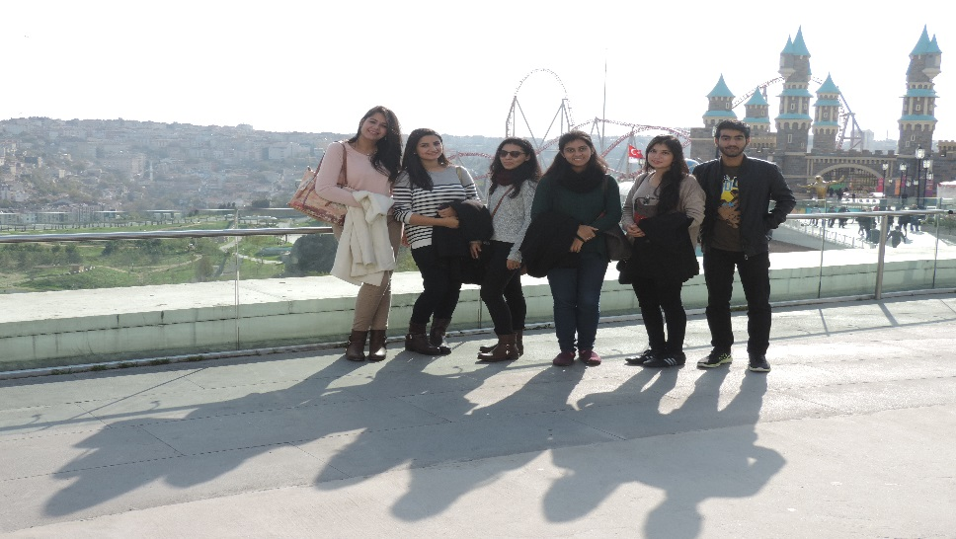

Six undergraduate students from Lahore School of Economics attended Winter Term, 2015 at Bahcesehir University, Istanbul, Turkey on full scholarship under the student Exchange Program. These students had a good experience of studying in the brother Muslim country and were deeply impressed with their culture and historical importance.

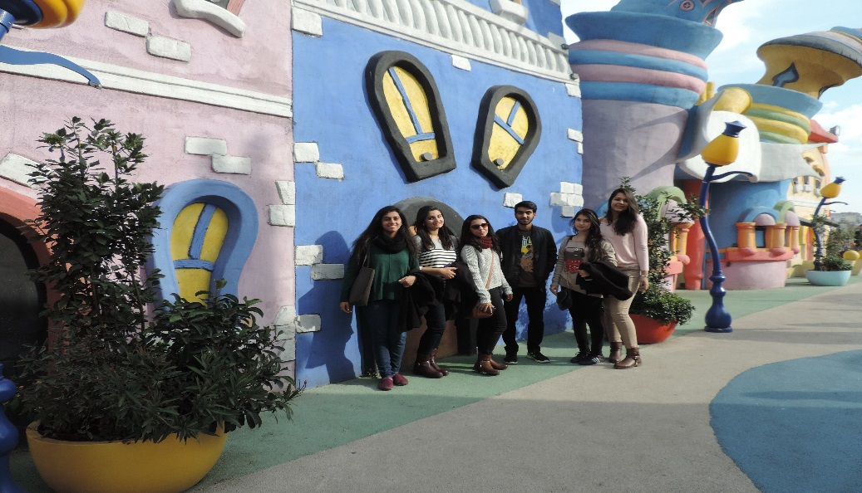

Alizeh Arif, Alizeh Khan, Arhum Mahmood, Danyal Tallat, Laiba Fatima and Wafa Shehraz are among the undergrad students who attended a semester at Bahcesehir University, Turkey.

___________________________________________________________________________

**12th International Business Conference on Business Management 2015**

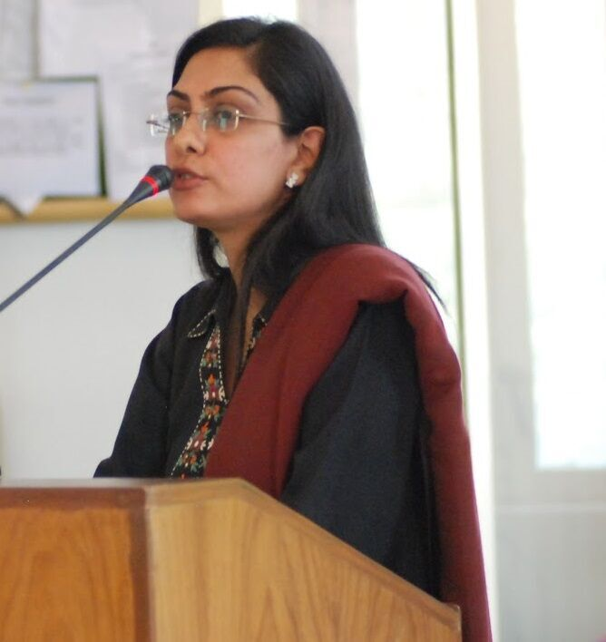

Dr, Ayesha Afzal, Assistant Professor, Lahore School of Economics attended the 12th International Business Conference on Business Management, in December 2015, which was held in Sri Lanka. The conference, with a theme of Sustainability, Governance and Ethics, was held with a purpose of bringing together academics and practitioners, with special reference to corporate and public sector organizations. Dr. Ayesha presented her paper, titled “Impact of Market Discipline on the Capital Adequacy of Banks: Evidence from an Emerging Economy”, which was selected as the best paper.

______________________________________________________________________________

**Dr. Waqar Wadho attends the16th Annual Conference of Public Economic Theory Association Conference**

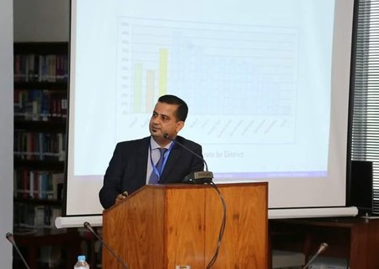

Dr. Waqar Wadho, Assistant Professor and Senior Research Fellow, Lahore School of Economics attended the 16th Annual Public Economic Theory Conference organized by Association for Public Economic Theory, held in Luxembourg in July 2015.

**Next already done**

**Conferences and Seminars Hosted by the Department of Economics**

**Microfinance and Enterprise Development – Research Prospects and Challenges**

The Center for Research in Economics and Business and University of Oxford jointly hosted a conference on the Microfinance and Enterprise Development – Research Prospects and Challenges on April 16, 2015. The conference was part of the ESRC-DFID project on ‘Microcredit and microsaving for small enterprises in Pakistan’. The conference brought together speakers from microfinance institutions, donors, academics and practitioners from Pakistan and outside of Pakistan. The conference highlighted the current and future research on microfinance with the purpose to start a conversation on the roles research can play in the future to help the sector achieve its goals of poverty alleviation, financial inclusion and sustainable enterprise growth. The conference was attended by Dr. Rashid Bajwa (CEO, National Rural Support Programme), Dr. Amjad Saqib (Founder and Executive Director, Akhuwat), Qazi Azmat Isa, Chief Executive Officer (Pakistan Poverty Alleviation Fund), Syed Mohsin Ahmed (CEO, Pakistan Microfinance Network), Dr. Simon Quinn (Associate Professor and Deputy Director, Centre for the Study of African Economies, University of Oxford), Matthew Titus (Former Founder Executive Director, Sa-Dhan), Sanjay Sinha (Managing Director, Micro-Credit Ratings International Limited (M-Cril), Ghazala Mansuri (Lead Economist, World Bank) .

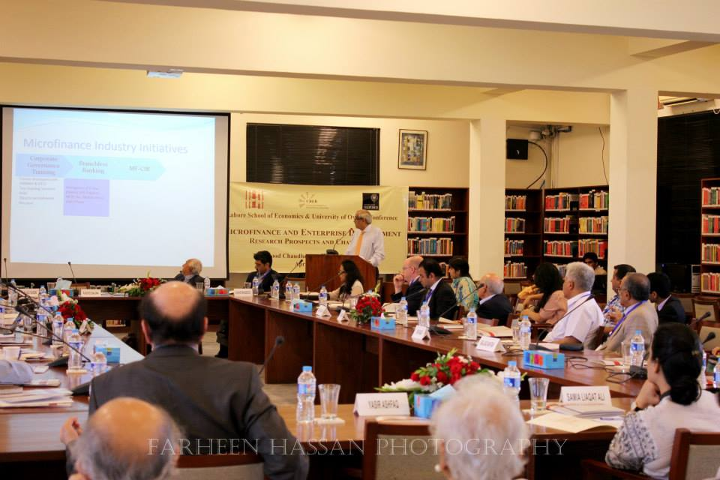

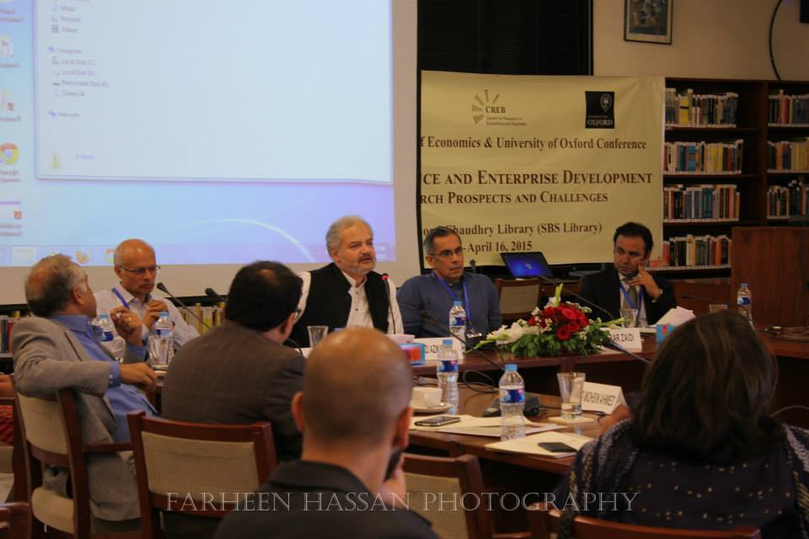

**Lahore School of Economics and World Bank Conference on Poverty**

The Lahore School of Economics and the World Bank jointly organized a brainstorming session on poverty measurement and policy at the Main Campus on 17 April 2015. The session was intended to get an open discussion going on issues in the measurement of poverty, and its implications for policy, and to facilitate the formation of an independent expert group to guide the process of arriving at a credible methodology and process for measuring and monitoring poverty.

**[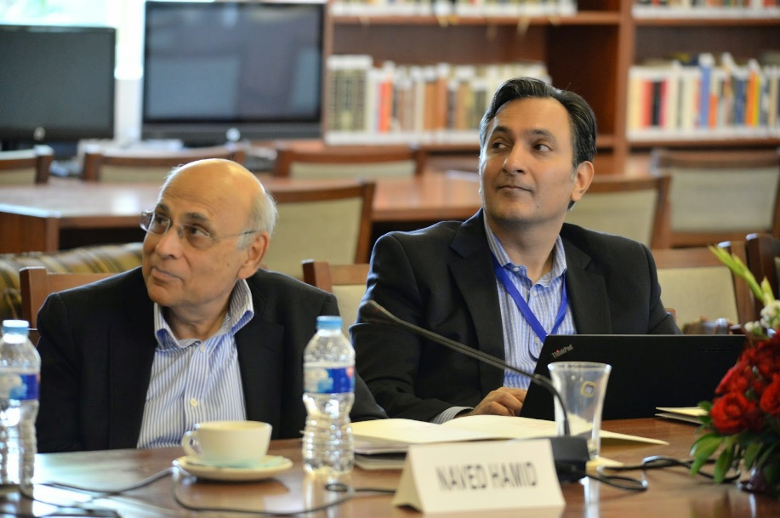](http://3.bp.blogspot.com/-0EuxwPnJwmw/VTnMGE_EUhI/AAAAAAAANDc/8ibyEYaeBtA/s1600/dr+azam+chaudhry.jpg)**

Opening comments were made by Dr. Shahid Amjad Chaudhry, Rector, Lahore School of Economics; Mr. Asif Bajwa, Chief Statistician, Pakistan Bureau of Statistics; and Dr. Naeemuz Zafar, Ministry of Planning Development and Reform. Following that, Dr. Ghazala Mansuri, Lead Research Economist at The World Bank gave a presentation on “Poverty debate in Pakistan: What accounts for the disconnect between the data and perceptions?” This raised issues for discussion on lack of confidence in the quality of official surveys such as the Pakistan Social and Living Standards Measurement Survey (PSLM) and the Household Income and Expenditure Survey (HIES), lack of confidence in the official consumer price index as a measure of inflation faced by the poor, especially in rural areas, concerns about the basket of goods and the calorie threshold used for estimating the poverty line, and the method used for tracking trends.

In response to Dr. Mansuri’s presentation, Dr. Naved Hamid, Professor and Director, Center for Research in Economics and Business (CREB), Lahore School of Economics, moderated the discussion that welcomed expert opinion and recommendations from distinguished poverty experts, academics and policy makers.

The debate aimed at aiding the process of initiating a joint effort by the Planning Commission, the Pakistan Bureau of Statistics and the World Bank, in establishing an independent expert group of highly credible academics and researchers.

**_________________________________________________________________________________________**

**Lahore School of Economics and Oxford University Conference on Microfinance and Enterprise Development**

The Lahore School of Economics in partnership with Oxford University hosted a conference on Microfinance and Enterprise Development. The objective of the conference was to bring together speakers from microfinance institutions, donors, academics and practitioners from Pakistan and outside of Pakistan. During this one-day event there was a detailed discussion on current and future research on microfinance with the purpose to start a conversation on the roles research can play in the future to help the sector achieve its goals of poverty alleviation, financial inclusion and sustainable enterprise growth. The conference was conducted as part of an on-going project on a comparison of Demand for Microcredit and Microsaving in a Framed Field Experiment in Rural Pakistan, which is funded by Economic and Social Research Council-Department of International Development (ESRC-DFID).

**[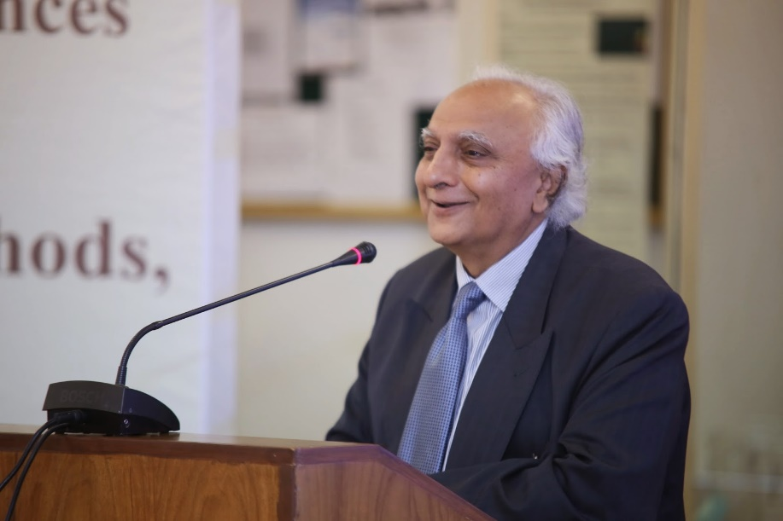](http://4.bp.blogspot.com/-SNN1CeN6tIg/U1JMTzPdpLI/AAAAAAAAKBU/mLecj6Vd1QM/s1600/lahore+school+of+economics.jpg)**

The conference started with welcoming remarks by Dr. Shahid Amjad Chaudhry (Rector, Lahore School of Economics). The keynote speech was delivered by Dr. Rashid Bajwa who showed that the microfinance sector in Pakistan has witnessed a tremendous growth – from 164 thousand borrowers in 2003 to 3.3 million borrowers in 2015. At present, there are 50 microfinance providers operating in the country. Moreover, the sector continues to attract foreign investment.

The first session of the conference focused on the current state and future directions of the microfinance sector. The chairperson for the session was Dr. Rashid Bajwa (Chief Executive Officer, NRSP). The session was conducted jointly by, Dr. Amjad Saqib (Founder and Executive Director, Akhuwat), Syed Mohsin Ahmed (Chief Executive Officer, Microfinance Network), Kamran Azim (Chief Operating Officer, Kashf Foundation), and Shahid Maqsood (Chief Operating Officer, FINCA Microfinance Bank Limited).Dr.Amjad Saqib gave a brief overview of the unique model of microfinance that Akhuwat is following, based on interest free loans. Syed Mohsin Ahmed discussed an impact assessment study, which PMN is planning to conduct in the near future in order to investigate the impact of microfinance loans on employment and job creation. Kamran Azimgave an overview of the current approach that is being followed by Kashf Foundation. The strategy focuses on (i) credit programs with existing businesses as well as start-ups (ii) A large scale financial literacy program (iii) a health insurance program as well as support for schools in low income areas and (iv) microsaving products.

The second session of the day served to disseminate and invite feedback on the current research being conducted by Lahore School on microfinance. The chairperson for the session was Kamran Azim (Chief Operating Officer, Kashf Foundation).

Simon Quinn (Associate Professor and Deputy Director, Centre for the Study of African Economies, University of Oxford)presented the first paper in the session (written jointly with Uzma Afzal, Giovanna d’Adda, Marcel Fafchamps, and Farah Said), while the discussant for the paper was Tahir Waqar (Senior Program Manager, National Rural Support Programme (NRSP)).

The paper is based on a recent pilot study conducted in Sargodha, which directly tested between the demand for microcredit and demand for micro-savings using a framed field experiment amongst women borrowers of NRSP participating in group lending arrangements in rural parts of Sargodha. The experiment involved randomly offering credit products and savings products to the same subject pool. The study concluded that a high demand exists for both credit products and for savings products implying that the distinction between micro-lending and micro-saving may be largely illusory; participants value a mechanism for regular deposits and lump-sum payments, whether that is structured in the credit or the debt domain. Fieldwork for the study is currently underway. A scaled up version of the study will be carried out later this year.

The session ended with a presentation by Uzma Afzal (Assistant Professor and Research Fellow, Centre for Research in Economics and Business, Lahore School of Economics) with Ghazala Mansuri (Lead Economist, World Bank) as the discussant. It was a preliminary presentation discussing the methodology for a project (to be conducted jointly with Giovanna d’Adda, Marcel Fafchamps, Simon Quinn and Farah Said) which aims to use behavioural games to understand how self-control problems and peer pressure affect take-up and outcomes of a financial product and secondly how access to saving and/or credit affect self-control problems and ability to resist peer pressures?

The third session of the day also focused on recent research that has been conducted in the microfinance sector in Pakistan. The first paper in this session was presented by Ghazala Mansuri (Lead Economist, World Bank), which was written jointly with Xavier Giné. The discussant for this paper was Ayesha Afzal (Assistant Professor, Lahore School of Economics). The main objective of the paper was to identify the relative importance of human and physical capital for entrepreneurship. Microfinance clients were offered business training and a loan lottery of up to seven times the average loan size. The paper concluded that business training increased business knowledge, reduced business failure, improved business practices and increased household expenditures by $46 per year. It also improved financial and laboral location decisions. Access to larger loans, in contrast, had little effect. Despite the positive impact on clients, business training was not cost-effective for the microfinance institution, explaining why few institutions offer training voluntarily.

Farah Said (Assistant Professor and Research Fellow, Centre for Research in Economics and Business, Lahore School of Economics) presented the second paper in the session (written jointly with Azam Chaudhry, Naved Hamid and Mahreen Mahmud). The discussant for this paper was Ommara Raza (Senior Manager Research, Kashf Foundation). The paper is based on a baseline survey for a Randomized Control Trial to evaluate the socio-economic and welfare impacts of micro-loans to female micro-entrepreneurs. The project is being conducted in collaboration with Kashf and the fieldwork is currently underway.

The final paper in this session was presented by Mahreen Mahmud (Phd Candidate, University of Kent). The discussant for the paper was Sajjad Akhtar (Member, Pakistan Microfinance Network Research Committee). The paper explored a unique microfinance model based on zero interest loans and voluntary contributions instead of one with a fixed interest charge. This model provides more scope for signaling to the borrowers especially in the case of joint liability contracts. Thus, the author investigated if patterns of giving and repeat borrowing are consistent with what would be expected of signaling behaviour.

The conference ended with a detailed panel discussion on the role of research in helping the microfinance sector achieve its objectives and in shaping its future. The chairperson for this session was Qazi Azmat Isa (Chief Executive Officer, Pakistan Poverty Alleviation Fund). The panel session was conducted jointly by Akbar Zaidi (Member Board of Directors, Pakistan Microfinance Network), Waqas-ul-Hasan (Private and Financial Sector Development Adviser, Department for International Development), Abanul Haq (Head Education Innovation Fund, Ilm Ideas), Mathew Titus (Former Founder Executive Director, Sa-Dhan) and Sanjay Sinha (Managing Director, Micro-Credit Ratings International Limited).

**IMF Chief Visits Lahore School to Meet Students**

On March 6th, 2015, the Lahore School of Economics hosted the IMF Director for Middle East and Central Asia, Mr. Masood Ahmed, who held a roundtable discussion with a group of students from local universities to discuss the IMF and its program in Pakistan. Students from the Lahore School of Economics, the Lahore College for Women University, the Lahore University of Management Sciences, Beaconhouse National University and Forman Christian College University attended the roundtable discussion to share their views with the visiting IMF team. The roundtable was chaired by Mr. Ahmed, Dr. Shahid Amjad Chaudhry, Rector of the Lahore School of Economics and Dr. Azam Chaudhry, Dean Faculty of Economics, Lahore School of Economics.

**[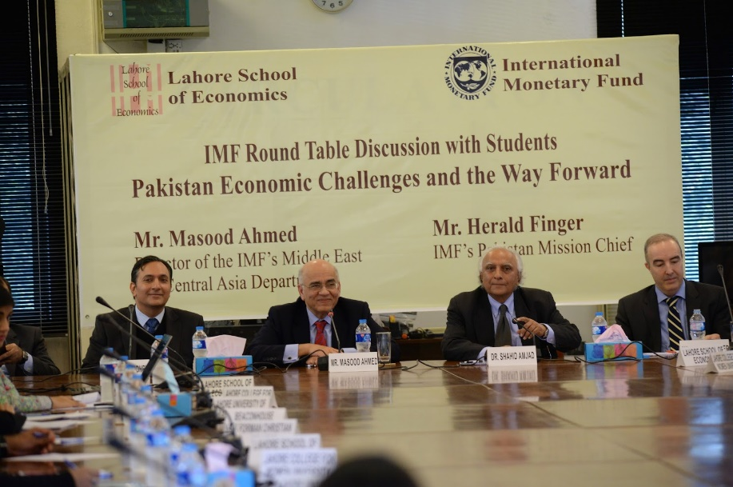](http://3.bp.blogspot.com/-6eBwCMjSb_Y/VPlz50VCqSI/AAAAAAAAMnU/JToVEnYq7O0/s1600/IMF+Picture+2.jpg)**

Dr. Shahid Amjad Chaudhry, Rector of the Lahore School of Economics welcomed Mr. Masood Ahmed, the IMF Director of the Middle East and Central Asia region, Mr. Herald Finger, the IMF Pakistan Mission Chief and Mr. Tokhir Mirzoev, the IMF Resident Representative for Pakistan. Dr. Chaudhry discussed the macroeconomic situation prevailing in Pakistan at the time when Pakistan entered the IMF program as well as the prevailing macroeconomic challenges faced by the country.

**[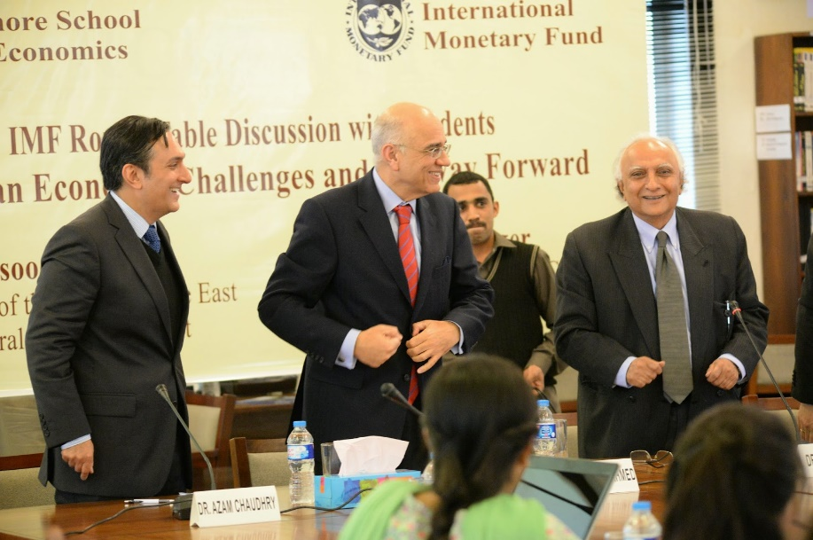](http://3.bp.blogspot.com/-khW1sWREGGY/VPl0oYNTNbI/AAAAAAAAMnc/aFlzNka818E/s1600/IMF+Picture+4.jpg)**

Mr. Masood Ahmed began by discussing the history and role of the IMF in the global economy and explained how the IMF assists countries in terms of technical assistance, macroeconomic advice and lending in case of macroeconomic crises. Mr. Ahmed then explained how the balance of payments problem that Pakistan faced in 2013 led to a significant reduction in its foreign exchange reserves which in turn led the Pakistani government to ask the IMF for assistance. Finally, Mr. Ahmed explained how the IMF was different from other international agencies like the World Bank and the Asian Development Bank because these other institutions focus on development assistance with lending for specific projects and initiatives while the IMF focuses on macroeconomic stabilization with a specific emphasis on fiscal deficits and exchange rate adjustments.

**[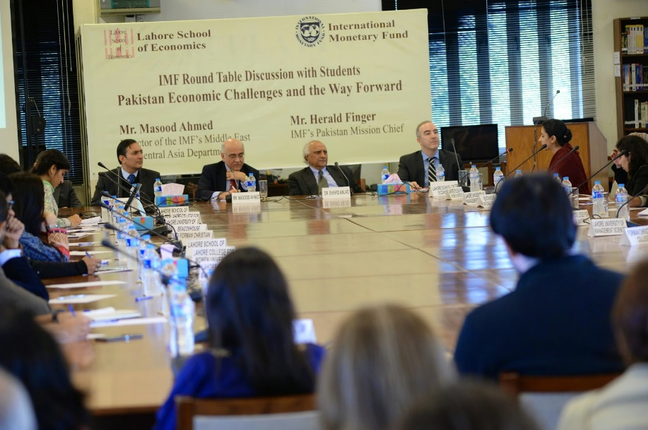](http://3.bp.blogspot.com/-4XvH0cBmYrc/VPl0_7DguJI/AAAAAAAAMnk/pNAsYBLAYRg/s1600/IMF+Picture+3.jpg)**

This introduction was followed by a series of questions regarding the role of the IMF in Pakistan. Many students asked Mr. Ahmed why the IMF insisted on significant reductions in expenditures which mostly led to significant reductions in development expenditures that could impact long term growth. At the same time other students asked why the IMF insisted on increasing tax revenues which in many cases led the government to adopt taxes that many considered regressive. Mr. Ahmed explained that one of the major issues facing developing countries like Pakistan is that countries spend far more money than they collect and this leads to macroeconomic problems. He then went on to explain that the IMF has recognized that governments tend to slash development expenditures immediately which means that there are significant reductions in spending for critical sectors like health and education. For this reason, the IMF now includes in its program a requirement that governments maintain a certain level of spending in critical social sectors. Mr. Ahmed also explained that the IMF does not get involved in determining specific taxes but is more concerned with the overall objective of macroeconomic stabilization.

**[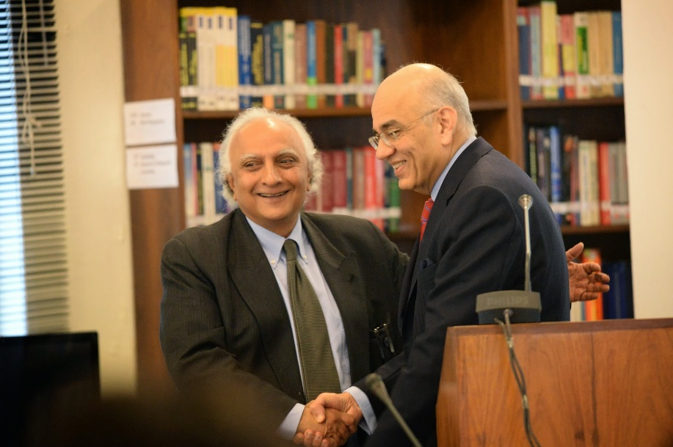](http://2.bp.blogspot.com/-l4yNWJmpuEQ/VPl4i1ylNxI/AAAAAAAAMn4/8-xsLWGPR1E/s1600/IMF+Picture+1.jpg)**

Another set of questions by the students focused on why Pakistan constantly kept reentering IMF programs but failed to complete any programs. Mr. Ahmed explained that these two issues were closely interlinked: Pakistan has some basic structural problems which become severe every few years and requires IMF assistance, but after a year or two of the IMF program the Pakistan government feels that the crisis has passed so they do not continue to take measures to address these issues. This has led to a cycle in which the Pakistan government asks for IMF assistance, stabilizes the economy, and then stops following IMF advice for long term reform which then leads to the same crisis reoccurring after a few years.

Finally, the students asked Mr. Ahmed’s views on the energy crisis facing Pakistan as well as the impact of falling oil prices on oil exporting countries (like those in the Gulf, or Nigeria an Venezuela) and oil importing countries like Pakistan. Mr. Ahmed says that the energy crisis in Pakistan is a significant issue facing policymakers as well those interested in macroeconomic stabilization and long-term growth and that the significant fall in oil prices has been handled differently by developing countries. Some countries like Pakistan have decided to pass on a portion of the fall in oil prices to the final purchasers, while others like India have kept the final prices of fuel the same by increasing the taxes on these products in order to shore by their domestic revenues. Mr. Ahmed also discussed how the significant decline in oil prices has had a major impact on the economies that are heavily reliant on oil and he also discussed the balance of payments impact of falling oil prices on countries like Pakistan.

**[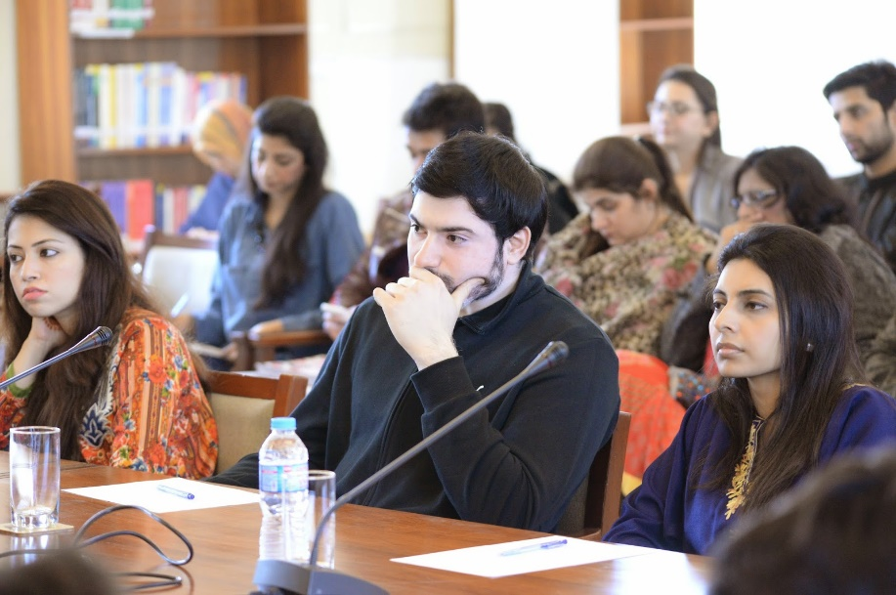](http://2.bp.blogspot.com/-9AbDmUgqGfU/VPl1YgnZcAI/AAAAAAAAMns/Yl5uJs0FCas/s1600/lse.jpg)**

Mr. Ahmed then ended the roundtable discussion by thanking Dr. Shahid Amjad Chaudhry, [**Dr. Azam Chaudhry**](http://lahoreschoolofeconomics.blogspot.com/2005/11/our-faculty-dr-azam-chaudhry.html), the student participants from various universities and the Lahore School of Economics for hosting this event. He told the audience that it was important for economists and macroeconomic policy makers to interact with students to understand the issues that were important to them and to society and to discuss long term economic strategies in order to develop inclusive policies that are understood and lead to long term growth.

**______________________________________________________________________________**

**Oxford Lecture on Conducting Research in Economics**

Dr. Simon Quinn, Associate Professor of Economics at the University of Oxford and Deputy Director of the Centre for the Study of African Economies at the University of Oxford, gave a lecture to the Lahore School Department of Economics on conducting research in economics and publishing research papers.

**[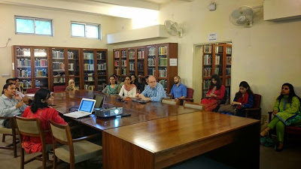](http://2.bp.blogspot.com/-yKKpPyrJieE/VAhNNZs2w1I/AAAAAAAALYE/HrgMptRuxiM/s1600/lahore+school+of+economics.jpg)**

Dr. Quinn is collaborating on research with the Center for Research in Economics and Business (CREB) at the Lahore School of Economics and his research interests are in development economics, focusing on the role of firms.

**Lahore School of Economics Hosts Former Greek Finance Minister**

“In Greece the GDP fell by 25% in five years, unemployment reached 28% while public debt as percent of GDP rose to 175% reflecting mainly the collapse of output,” according to [**Dr. Yannos Papantoniou**](http://www.gids.org.pk/Download/Papantoniou.pdf) in a lecture delivered at the Lahore School of Economics May 5, 2015.

**[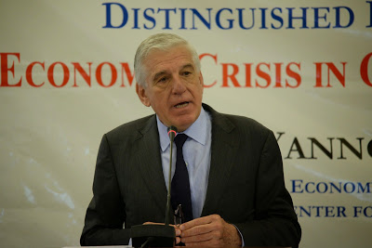](http://3.bp.blogspot.com/-Bz-ym3tsD2M/VUiRZR06pOI/AAAAAAAANG8/P4zwzwUltWs/s1600/Dr.+Yannos+Papantoniou.jpg)**

Dr. Papantiniou, Former Economy and Finance Minister of Greece (1994-2001) and President of the Centre for Progressive Policy Research, in his lecture “Economic Crisis in Greece and the Future of the Euro” was of the view that if talks between the lenders (ECB, IMF, and the EU) and Greece stall, Greece’s economy would sink further into recession, and social tensions would rise as living standards would register a further sharp decline.

**[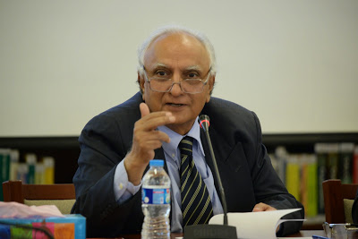](http://4.bp.blogspot.com/-FHmRT42MtqI/VUiRhyOupwI/AAAAAAAANHE/RVZmKf4Cc3c/s1600/dr+shahid+amjad+chaudhry.jpg)**

He emphasized that Greece’s economic problems did not arise during the process of acceding to the euro area, but began when large current imbalances emerged among member countries soon after the currency union’s creation in 2000. Massive current account deficits in the weaker economies led to the accumulation of public and private debt while the northern Europeans were running surpluses. The policies that the eurozone has initiated to tackle the debt crisis have been inadequate and even self-defeating. 

**[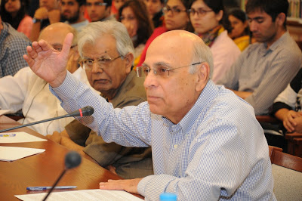](http://2.bp.blogspot.com/-XSJfR0s5qKk/VUiRpsvStsI/AAAAAAAANHM/unIZE86KKmw/s1600/DSC_0310.jpg)**

“Greece’s never ending economic crisis revealed critical flaws and weaknesses in the eurozone’s constitution,” according to Dr. Papantiniou, who is currently a visiting Professor at the Lahore School of Economics. He was of the view that in a currency union, individual economies cannot alter their exchange rates to account for changes in relative competitiveness. The resulting price stickiness tends to delay macroeconomic stabilization and structural adjustment, leading to rising debt and unemployment in weaker economies. Without free labour mobility, fiscal transfers are the euro area’s only option to ease debt repayment and, by stimulating economic activity, boost employment.

Moving to a fiscal union, along the lines of the U.S. Federal model, will not be easy according to Dr. Papantoniou, as it requires a resource that is in short supply in Europe today: mutual trust, particularly between the north and the south. Binding the union closer together could prove critical to building such trust. One strategy that combines rationality with the gradualism needed to overcome political resistance would be to increase the union’s central budget so that it can ultimately play a macroeconomic role, promoting stability and reinforcing cohesion in the euro area. He stressed that “it is a tough sell, but also a vital one.”

**[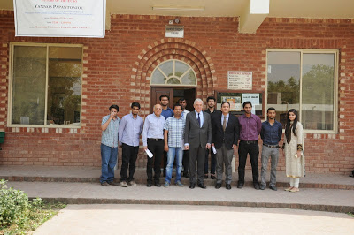](http://1.bp.blogspot.com/-_KHLJIeUi9U/VUiRwy6ARVI/AAAAAAAANHU/3ZJupZm7bSs/s1600/DSC_0396.jpg)**

He noted that Asia is the continent of the future, with China and India as giant economic players. The more integration within Asia, the strong it will become and Pakistan would only gain by strengthening ties with its neighbors China and India. He cautioned against moving too fast and instead take it step by step in order to minimize risks.

**Talk on The West and the Rest in the World Economy by Dr. Deepak Nayyar**

As part of the Distinguished Economist Seminar Series, the Lahore School Economics Society (LSES) organized a seminar on February 26, 2015. The guest speaker was a renowned Indian economist Dr. Deepak Nayyar who talked about “The West and the Rest in the World Economy: The Next Transformation” based on his recent book ‘Catch Up: Developing Countries in the World Economy’. The seminar was attended by distinguished professors and economists including Dr. Shahid Amjad Chaudhry (Rector, Lahore School of Economics), Dr. Rashid Amjad (Director the Graduate Institute of Development Studies (GIDS)), Dr. Azam Chaudhry (Dean, Department of Economics, Lahore School of Economics), Dr. Naved Hamid (Director, Center for Research in Economics and Business) and Dr. Irfan-ul-Haque (Special Advisor for Financing for Development, South Centre, Geneva), faculty members of Lahore School and a large number of both graduate and undergraduate students of Lahore School.

**[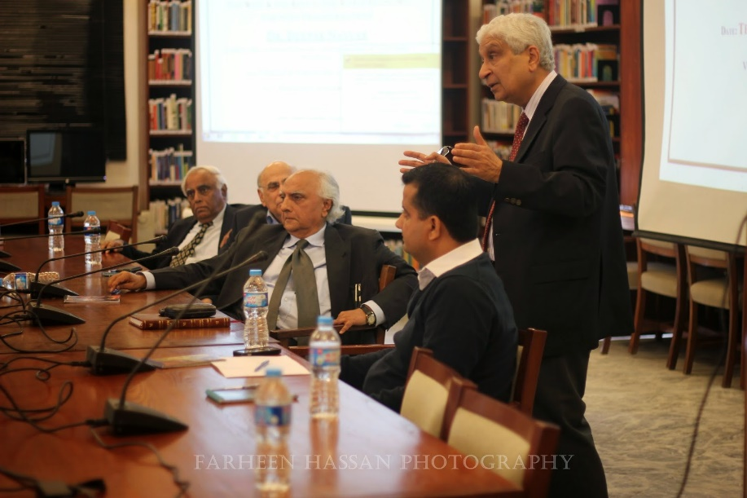](http://2.bp.blogspot.com/-oTv42IWlkFI/VPFhagAe6XI/AAAAAAAAMkM/i1fDFmksLfw/s1600/dr+shahid+chaudhry.jpg)**

Dr. Deepak in his talk provided a comprehensive overview of the evolution of developing countries in the world economy, situated in a long term historical perspective, from the onset of the second millennium but with a focus on the second half of the twentieth century and the first decade of the twenty-first century. He highlighted the overwhelming significance of what are now developing countries in the world until 200 years ago to trace their decline and fall from 1820 to 1950. Dr. Deepak emphasized that there is no single formula for growth and different sets of policies seem to have worked well in different settings, but economies relying on market as driving force have minimized market failures and those relying on government as central have minimized government failures. Also, growth has often not been transformed into meaningful development that improves the wellbeing of people. However, he optimistically asserted that the beginnings of a shift in the balance of power in the world economy are discernible and developing countries can sustain this rise only if they can transform themselves into inclusive societies where economic growth, human development and social progress move in tandem.

**[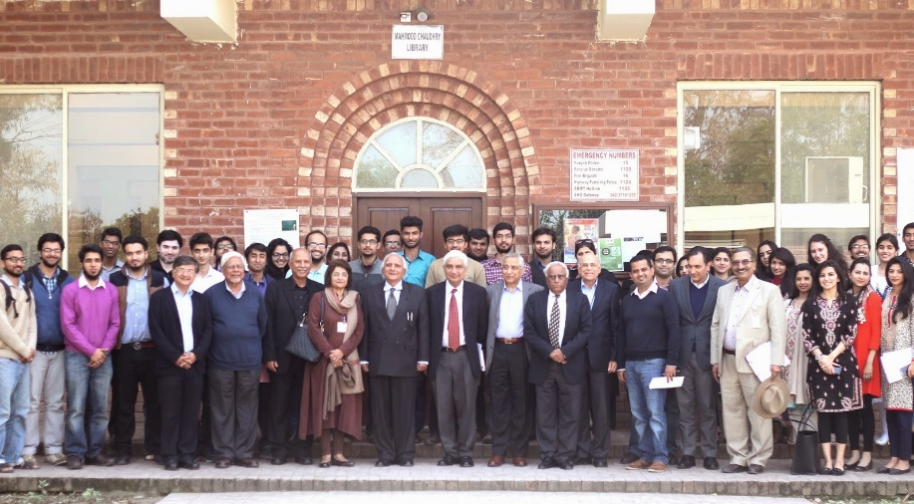](http://3.bp.blogspot.com/-NytbfqGHMlM/VPFhuFBO98I/AAAAAAAAMkU/bWQmxg_ScPw/s1600/dr+azam+chaudhry.JPG)**

The seminar was followed by a discussion session with the faculty and students which was moderated by Dr. Shahid Chaudhry himself. The seminar concluded with a brief speech by Dr. Shahid who welcomed the visit of such highly distinguished economists like Dr. Deepak Nayyar from India stating that such academic visits could provide opportunities for collaboration between India and Pakistan both in the academic and research front.

**Lecture on Reigniting Economic Growth in Pakistan by Dr. Rashid Amjad**

As part of the Distinguished Economist Seminar Series, the [**Lahore School Economics Society (LSES)**](http://lahoreschoolofeconomics.blogspot.com/2014/11/lahore-school-economics-society.html) organized its first seminar on February 18, 2015. The guest speaker was a renowned Pakistani economist Dr. Rashid Amjad who talked about “Re-igniting economic growth in Pakistan”. The seminar was chaired by the patron LSES, Dr. Waqar Wadho and was attended by distinguished professors and economists including Dr. Shahid Amjad Chaudhry (Rector, Lahore School of Economics), [**Dr. Azam Chaudhry**](http://lahoreschoolofeconomics.blogspot.com/2005/11/our-faculty-dr-azam-chaudhry.html)(Dean, Department of Economics, Lahore School of Economics), Dr. Sohail Zafar, (Dean, Department of Business Administration), Dr. Naved Hamid (Director, Center for Research in Economics and Business) and Dr. Irfan-ul-Haque (Special Advisor for Financing for Development, South Centre, Geneva), Dr. Shakil Faruqi (Professor, Lahore School of Economics), faculty members of Lahore School and a large number of both graduate and undergraduate students of Lahore School.

**[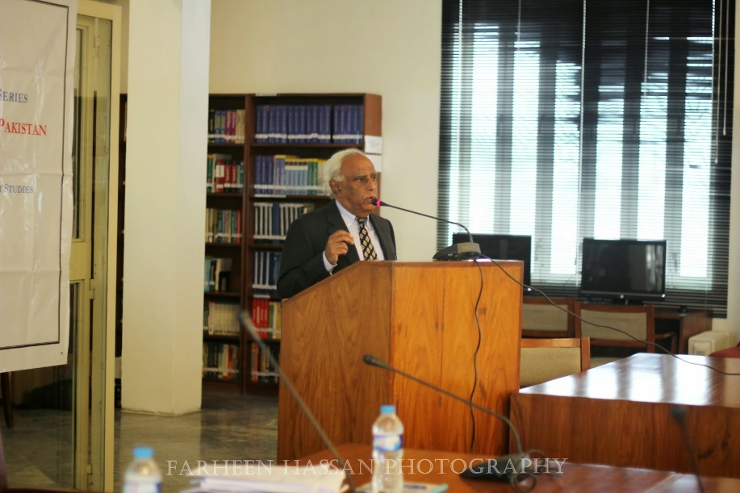](http://4.bp.blogspot.com/-EVNp5c_l4p8/VOwPajjo_XI/AAAAAAAAMiY/tvc3g3Yf-qE/s1600/dr+rashid+amjad.jpg)**

Given his expertise on the management of Pakistan economy, Dr Rashid focused this seminar on the issue of economic growth in Pakistan. He started off the analysis by providing a very comprehensive overview of the performance of Pakistan economy in the past decades and highlighted the need to focus on the ‘binding constraints’ that hamper growth. He argued that foreign exchange has been a binding constraint for decades. In recent years, due to inadequate focus on energy, today, the most important constraint that the Pakistan economy faces is the energy shortage and therefore, the government should target this as its highest priority. He suggested that the falling oil prices present a window of opportunity which should be exploited to alleviate the existing constraints. In his concluding remarks, Dr. Rashid advised the young economics students to focus on the underlying theory and fundamentals of economic policy-making along with thinking out-of-the-box so that more creative yet pragmatic solutions to the existing economic problems can be suggested.

**[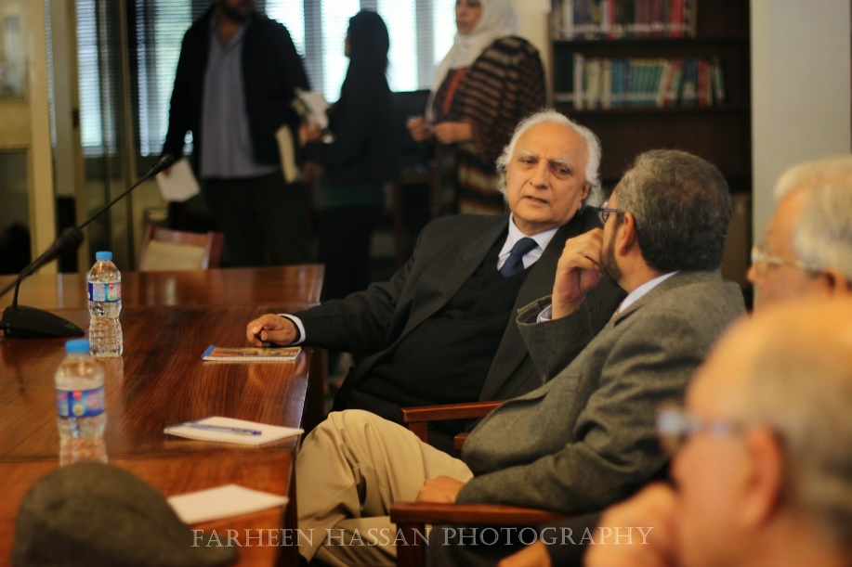](http://3.bp.blogspot.com/-SDp0nApiS40/VOwPkEag-0I/AAAAAAAAMig/9-x78QwXKXc/s1600/dr+shahid+amjad.jpg)**

**Orientation of Lahore School Economics Society**

The Lahore School Economics Society (LSES) organized its first orientation on November 17, 2014. Dr.Shahid Amjad Chaudhry, the Rector Lahore School was the guest of honour. A large number of students and faculty (including Dr. Azam Chaudhry, Dr. Theresa Chaudhry, Shamyla Chaudry and members of executive council) attended.

**[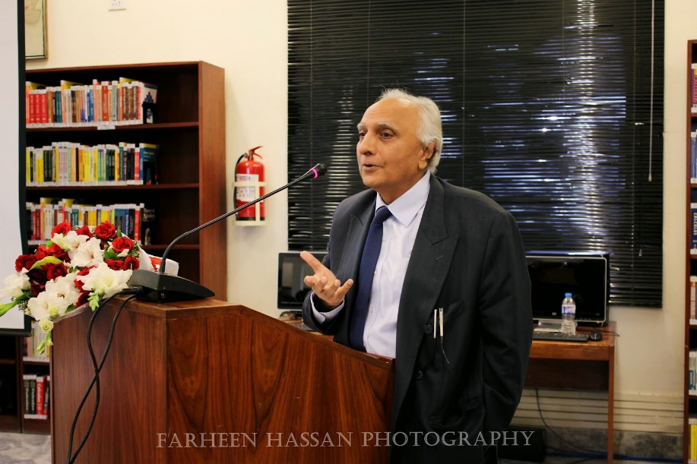](http://1.bp.blogspot.com/-IUQfsehw2qw/VHQVBXNndOI/AAAAAAAAL-w/q_Dn4HX8sDk/s1600/dr+shahid+amjad+chaudhry+lrector+ahore+school+of+economics.jpg)**

First, Dr. Waqar Wadho the Patron of Society thanked Dr. Shahid Amjad for providing this platform and addressed students that LSES aims to provide them with a platform to connect with fellow Economics students within and outside LSE (within and outside Pakistan), to connect with eminent economists (Pakistani and foreigners) and to connect with professionals (including LSE alumni) to form a vibrant economics community that is more informed, engaged and aware of the scope of opportunities and relevance of economics.

**[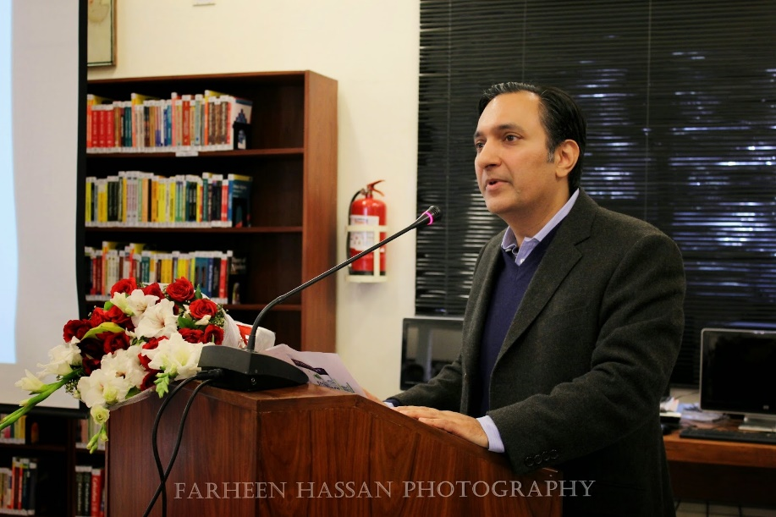](http://3.bp.blogspot.com/-ZBDXsPGK7tM/VHQaURJ2PJI/AAAAAAAAL_Q/0DCYdcd7y7w/s1600/dr+azam+chaudhry.jpg)**

The President and Vice President of the LSES Council briefed attendees about the proposed activities that include lectures/guest speaker sessions and seminars with economists and other professionals; competitions including an international essay competition, yearly national budget sessions, and quiz competitions; regular sessions with the Dean/Rector; and creation of a central information system that would actively gather information on different opportunities available for students pursuing Economics.

This was followed by an address by [**Dr. Theresa Chaudhry**](http://lahoreschoolofeconomics.blogspot.com/2005/11/our-faculty-dr-theresa-chaudhry.html), Senior Faculty Member, who enlightened students about the ongoing research collaborations between the Lahore School of Economics and other universities including Oxford, Columbia, Yale and Warwick, and international institutions such as the International Growth Center. These collaborations have led to research on microfinance, distribution of public services, and manufacturing including the football, fans, and garment sectors.

**[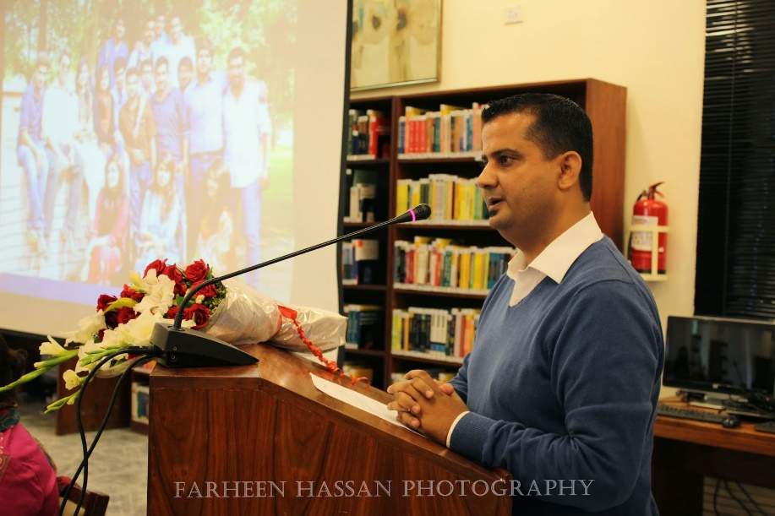](http://1.bp.blogspot.com/-OWGIdw9APoU/VHQakQp0QzI/AAAAAAAAL_Y/UmOTbNoOdZU/s1600/lahore+school.jpg)**

Then, [**Dr. Azam Chaudhry**](http://lahoreschoolofeconomics.blogspot.com/2005/11/our-faculty-dr-azam-chaudhry.html), Dean Faculty of Economics addressed the gathering and greatly applauded the efforts of the Society. He spoke about different collaborations and exchange programs with international universities (Lahore School-Oxford doctoral exchange program and Memorandums of understanding which cover areas like student and faculty exchange with [**Bahçeşehir University**](http://lahoreschoolofeconomics.blogspot.com/2012/05/renewal-of-mou-with-bahcesehir.html) in Turkey, [**University of Colombo**](http://lahoreschoolofeconomics.blogspot.com/2010/08/cooperation-between-lahore-school-of.html) in Sri Lanka and with [**Macquarie University**](http://www.lahoreschoolofeconomics.blogspot.com/2014/11/lahore-school-collaboration-with.html) in Australia. Dr. Azam also discussed a variety of different course combinations offered at the School that makes it a unique institution, as well as the job market and scholarships prospects for economics students.

Dr. Shahid Amjad Chaudhry, Rector, Lahore School of Economics congratulated the Council and the Society members for this initiative. Dr. Shahid Amjad elaborated on both the teaching and research sides of the Lahore School that make it what it is. He told students that the course combinations and teaching facilities at Lahore School are of high standards, this is evident from the recent acknowledgement by the [**National Business and Accreditation Council that gave Lahore School the highest ratings in Pakistan**](http://lahoreschoolofeconomics.blogspot.com/2014/06/congratulation-lahore-school.html). He informed students that the Lahore School produces top quality research that is published in international journals, and both the government and private sectors repeatedly seek policy guidance from Lahore School researchers. What makes it even more unique is that Lahore School researchers do not charge for these research studies and they are done purely for academic purposes.

**[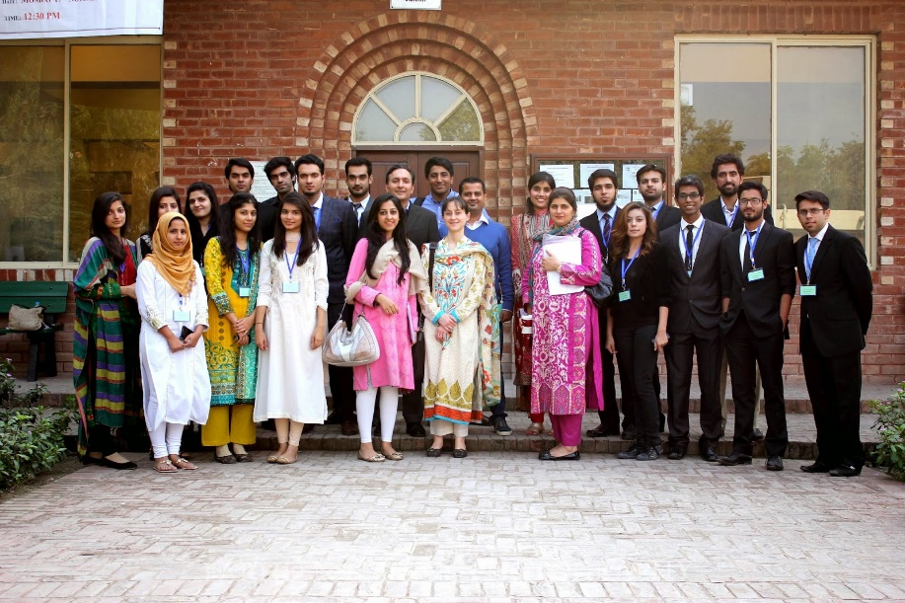](http://3.bp.blogspot.com/-1ro5_t79VNg/VHQVj0iG4NI/AAAAAAAAL_A/VkXjPj1kZ_I/s1600/dr+azam+chaudhry.jpg)**

**_____________________________________________________________________________**

**Presentations by the Faculty of the Lahore School of Economics**

The Economics Department hosted both visiting faculty and its own faculty to discuss some of the cutting edge research that they are conducting. These presentations included:

1. Dr. Simon Quinn, Associate Professor of Economics at the University of Oxford and Deputy Director of the Centre for the Study of African Economies at the University of Oxford, gave a lecture to the department of economics on conducting research in economics and publishing research papers. Dr. Quinn is collaborating on research with the Center for Research in Economics and Business (CREB) at the Lahore School of Economics and his research interests are in development economics, focusing on the role of firms.
2. Ms. Mahreen Mahmud presented on: Analysis of Small Donations - An Exploration of a Unique Microfinance Model.
3. Ms. Mahnoor Asif presented on “The Role of Socio-Economic Networks in Lahore for the General Elections 2013.”
4. Ms. Alishae Khar presented on “The Impact of Un-Conditional Cash Transfers on Child Education: Analyzing Pakistan’s Largest Social Safety Program (BISP).”
5. Ms. Maha Ikram presented on “Effects of Birth Order on Child Nutritional Status.”
6. Ms. Anum Elahi presented on “Corruption, Tax Evasion, and Economic Growth in Economies with Hierarchical Tax Administration System.”
7. Ms. Anam Masood presented on “Girl's Secondary Stipend Program in Punjab- A Panel Data Analysis,” Supervised by Dr. Theresa Chaudhry.
8. Ms. Ayesha Syed presented on “Fuzzy Judgment Aggregation: Methods Based on Distance,” Supervised by Dr.Ismat Baig & Dr.Naved Hamid.
9. Ms. Sadia Hussain presented on “Ethnic Polarization, Resource Curse and Income Inequality,” and Mr. Taimoor Naseer presented on “Cognitive Reflection and Decision Making.”
10. Ms. Sara Khan presented on “Health and Economic Growth,” and Ms. Yumna Hasan presented on “International Migration, Remittances and Economic Growth.”
11. Ms. Amber Masood presented on “Domestic Violence, Female Empowerment and the Uptake of Maternity Care Services.”
12. Anam Masood presented on “Impact of Female Secondary School Stipend Program on Enrollment and Marriage Outcomes in Punjab,"
13. Ayesha Syed presented on “Fuzzy Judgment Aggregation: Distance Based Methods.”
14. Hafsa Tanveer presented on "Unique and Multiple Equilibria in a Macroeconomic Model with Environment: Stability Analysis and Transitional Dynamics."
15. Anam Masood presented on "Impact of Female Secondary School Stipend Program on Enrollment, Marriage and Fertility Outcomes in Punjab."
16. Amber Masood presented on "Female Empowerment and the Uptake of Maternity Care Services in Pakistan."

______________________________________________________________________________